**Software Construction and Development**

**ASSIGNMENT NO: 3**

Deployment using Minikube

**Submitted to**

Mr, Zaheer Sani

**Submitted by**

21i-1233 Anum



Contents

**Introduction** 3

**Docker Files** 3

Backend 3

Frontend 4

**Push Images to Docker Hub** 6

**MiniKube** 8

**Episode 01** 10

**Episode 02** 11

**Episode 03** 12

**Episode 04** 13

**Episode 05** 13

**Kubernetes Dashboard** 14

Setup 14

Successful 14

View all deployments 16

Scaling the episode 5 to 6 replicas 17

# **Introduction**

In this assignment, we utilized Minikube to deploy various applications and accessed them through port forwarding using localhost. Minikube is an open-source tool that enables us to run a single-node Kubernetes cluster on our local machines. It operates a virtual machine (VM) on our computer, setting up a Kubernetes control plane within this VM. This setup allows us to explore Kubernetes features and deploy applications as if working with a multi-node cluster. However, for this particular assignment, we created a cluster named "multinode" with 5 nodes. One node served as the control plane, while the other nodes were responsible for deploying different episodes, with each node hosting at least two episodes.

# **Docker Files**

## Backend

* **FROM node:14**

This line specifies the base image for the Docker image. In this case, it uses the official Node.js image version 14. This image includes Node.js and npm (Node Package Manager) pre-installed.

* **WORKDIR /app**

This line sets the working directory inside the Docker container to /app. All subsequent commands will be executed from this directory.

* **COPY package*.json ./**

This line copies the package.json and package-lock.json files from the host machine to the working directory in the Docker container. These files contain the dependencies for the Node.js application.

* **RUN npm install**

This line runs npm install inside the Docker container. It installs all the dependencies listed in the package.json file.

* **COPY . .**

This line copies all the files from the host machine's current directory to the working directory in the Docker container. This includes the application source code and any other necessary files.

* **EXPOSE 8000**

This line informs Docker that the container listens on port 8000.

* **CMD ["node", "src/server.js"]**

This line specifies the command to run when the container starts. In this case, it runs the server.js file located in the src directory using Node.js.

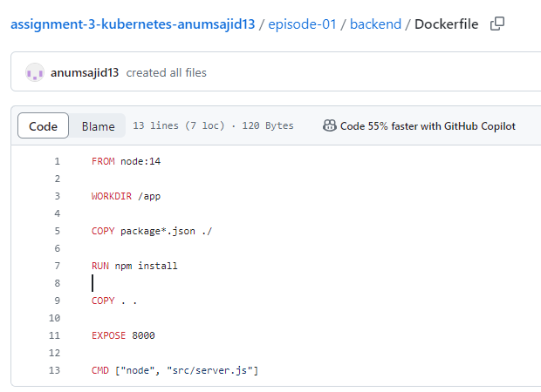

## Frontend

* **FROM node:14 as build**

This line specifies the base image for the Docker image, using the official Node.js image version 14. The as build part gives this stage a name, allowing you to reference it later if you use multi-stage builds.

* **RUN apt-get update && apt-get install -y curl**

This line updates the package list in the container and installs the curl utility. The -y flag automatically answers "yes" to prompts during installation.

* **WORKDIR /app**

This line sets the working directory inside the Docker container to /app. All subsequent commands will be executed from this directory.

* **COPY package*.json ./**

This line copies the package.json and package-lock.json files from the host machine to the working directory in the Docker container. These files contain the metadata and dependencies for the Node.js application.

* **RUN npm install**

This line runs npm install inside the Docker container. It installs all the dependencies listed in the package.json file.

* **RUN npm install -g serve**

This line installs the serve package globally in the Docker container. serve is a simple static file server for serving the built application.

* **COPY . .**

This line copies all the files from the host machine's current directory to the working directory in the Docker container. This includes the application source code and any other necessary files.

* **RUN npm run build**

This line runs the build script defined in the package.json file. This script typically compiles the application into a production-ready static bundle, often placing the output in a build directory.

* **EXPOSE 80**

This line informs Docker that the container listens on port 80.

* **CMD ["serve", "-s", "build"]**

This line specifies the command to run when the container starts. It uses the serve package to serve the static files from the build directory, with the -s flag indicating that the serve command should serve the single-page application (SPA) in a static mode.

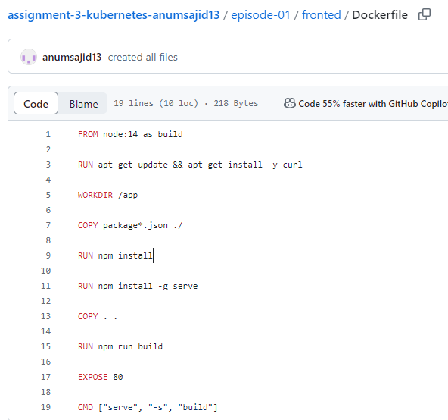

# **Push Images to Docker Hub**

* Created Dockerfiles for both the frontend and backend of all five episodes.
* Created a docker-compose.yml file to define and manage multiple containers, specifying all necessary services, volumes, and ports for the applications.
* Used the docker compose build command to build images for all the services defined in the docker-compose.yml file. This command checks each service configuration and builds new images based on the specified Dockerfile locations.
* Built all containers and images locally on Docker Desktop.
* Logged in to Docker Hub and pushed the images into a repository named "assignment."
* Ran docker compose up to ensure there were no errors in the files or images.

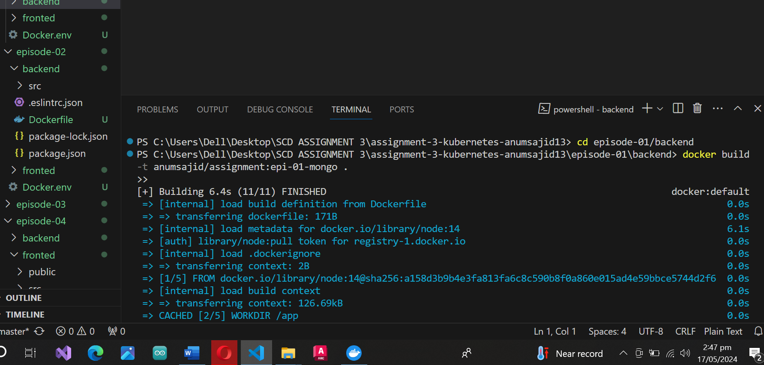

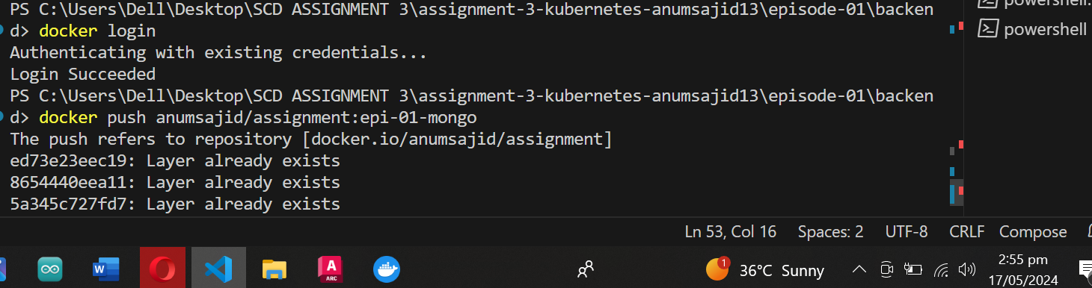

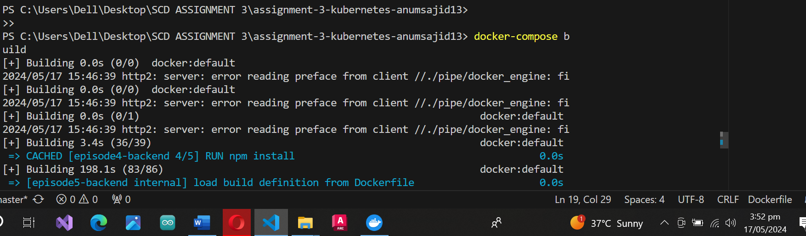

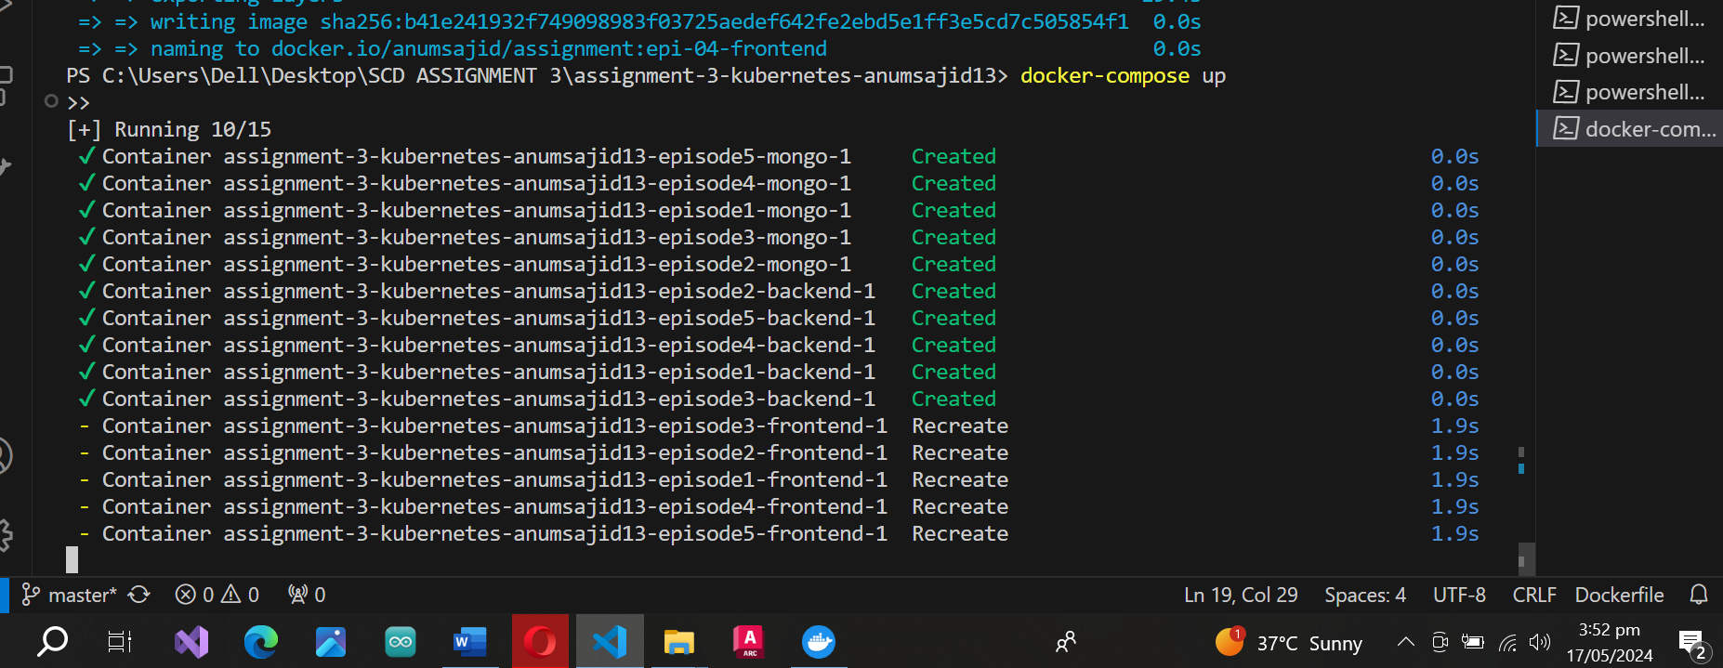

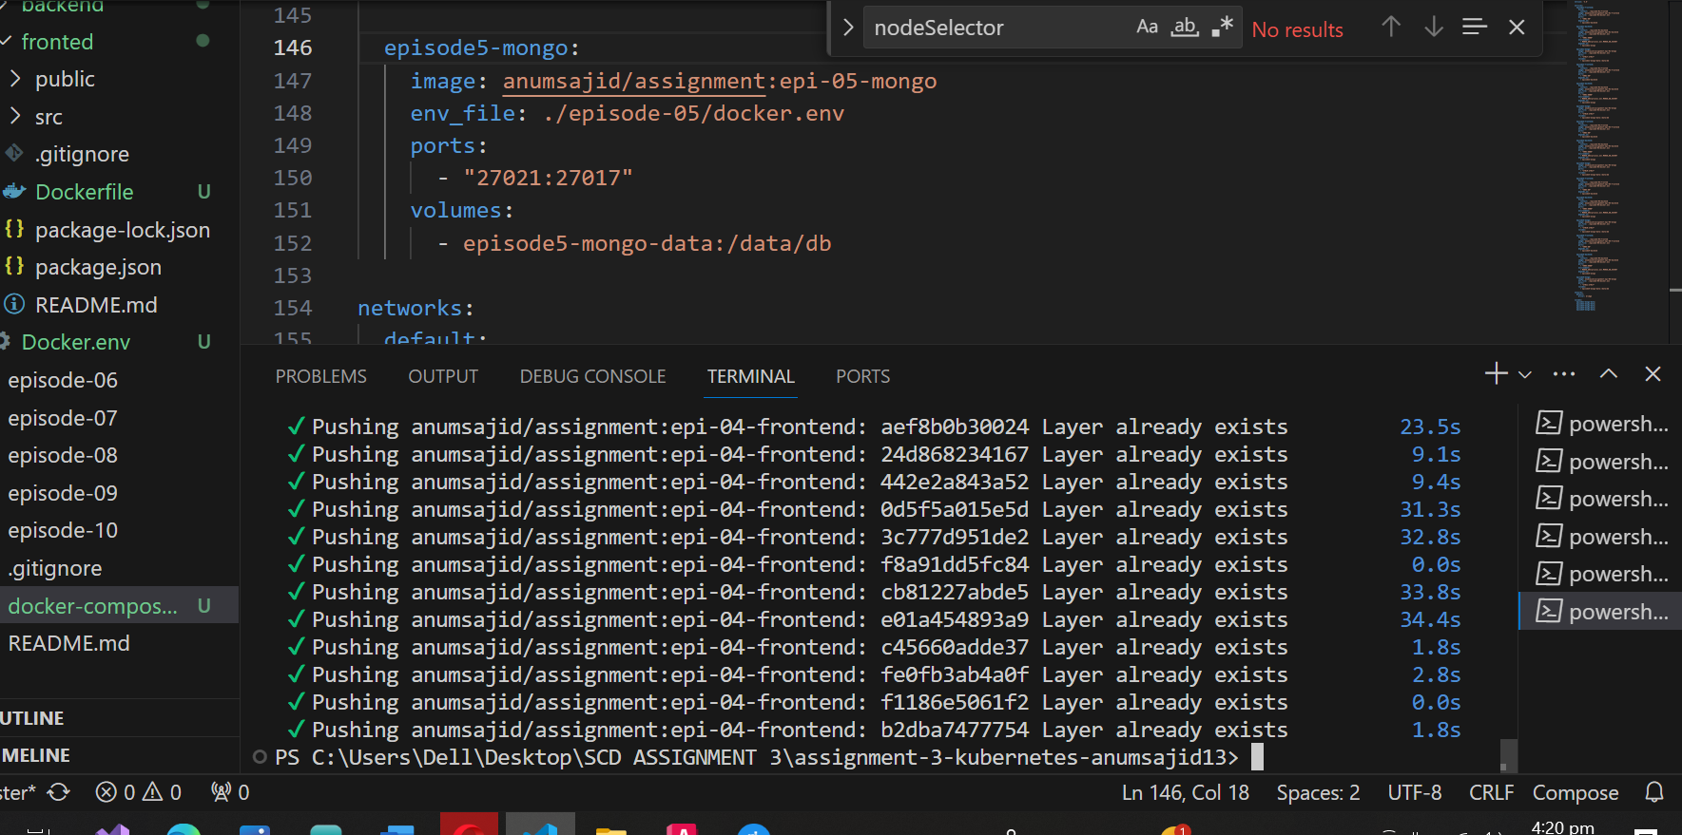

Below are the images that were pushed to the docker hub:

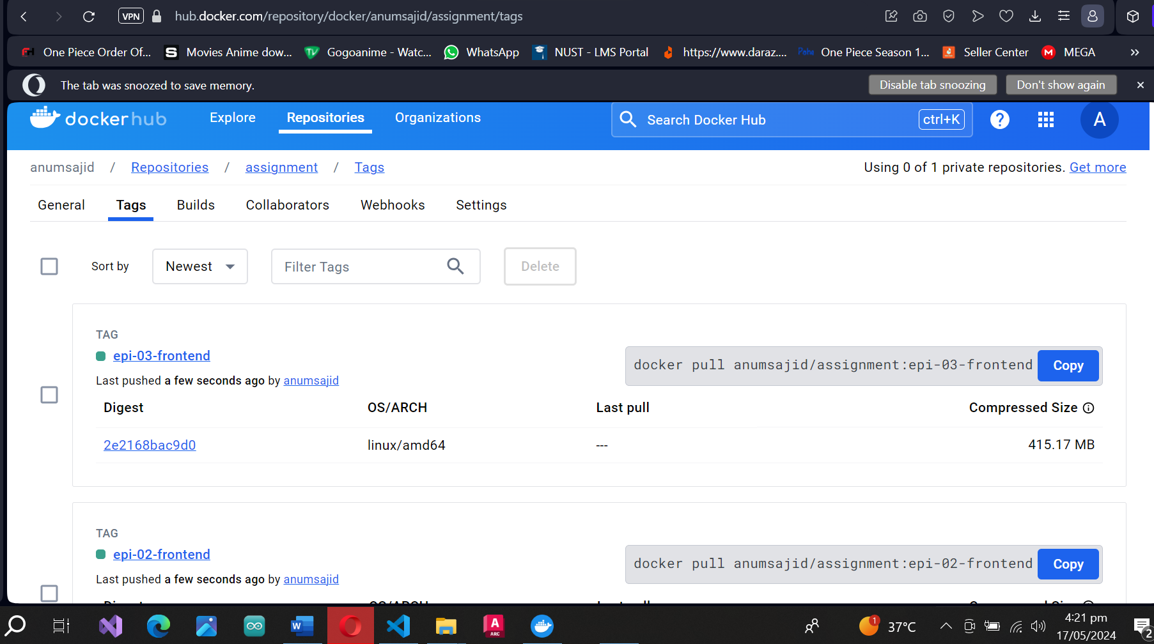

# **MiniKube**

* First, start Minikube and create a 4-node cluster.
* **kubectl apply -f deployement.yaml :** This command reads the YAML file and creates the defined resources such as Pods, ReplicaSets, Deployments, etc.
* **kubectl apply -f service.yaml:** This command creates a service in Kubernetes that provides a network identity for a set of pods (containers). It allows pods to be discovered and accessed by other services or applications within the cluster.
* **kubectl port-forward service/episode1-service 8080:80:** This command forwards traffic from port 8080 on my local machine to port 80 on the specified service

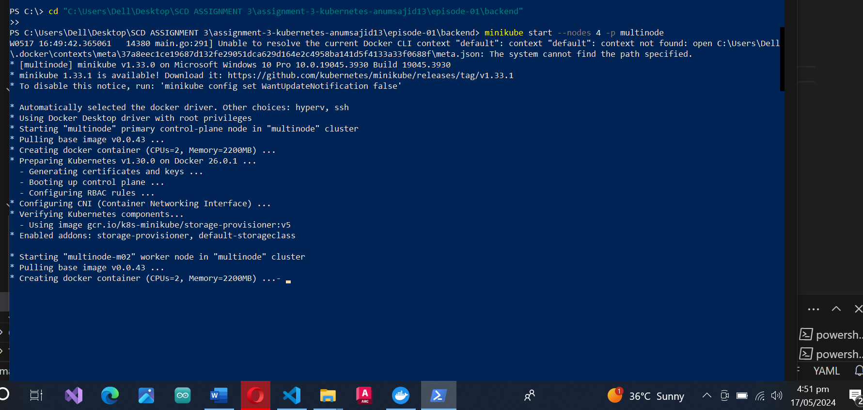

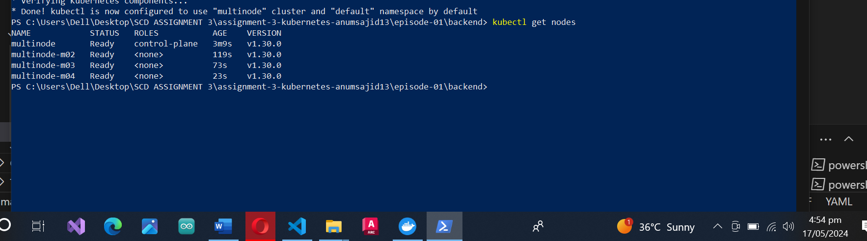

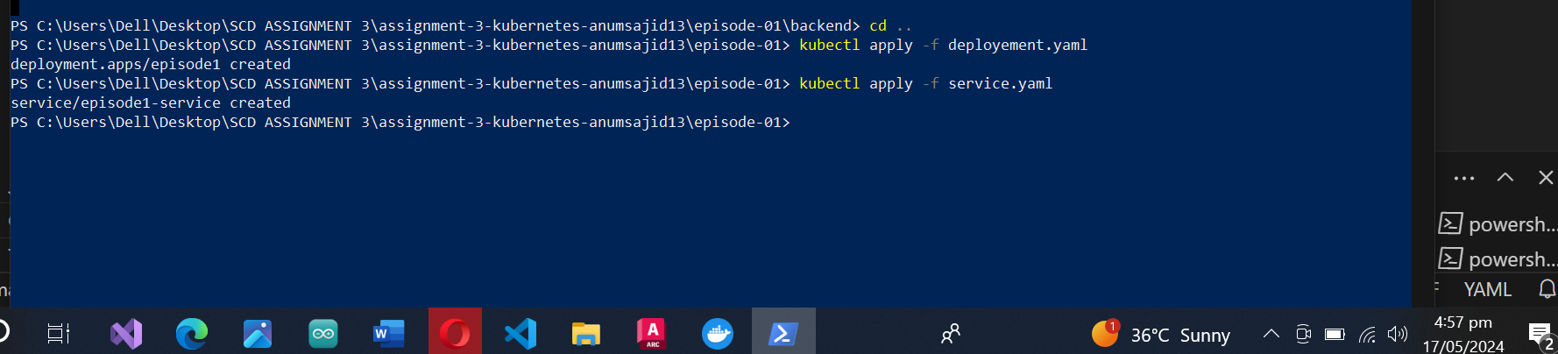

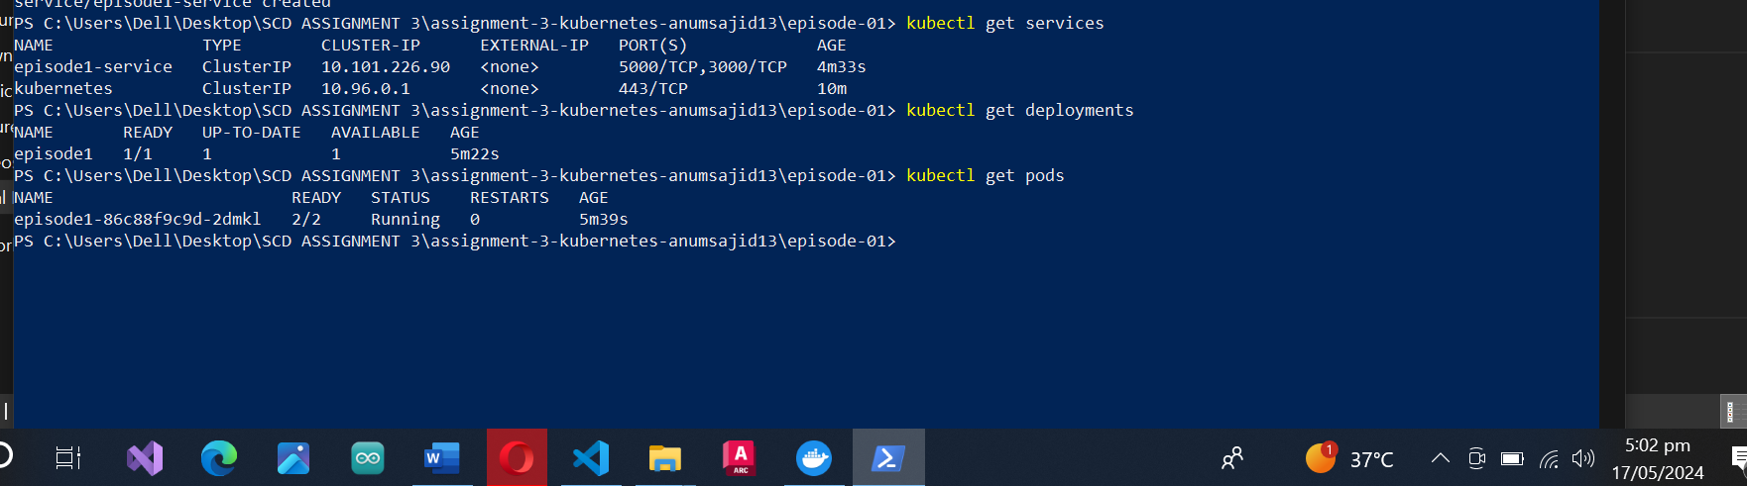

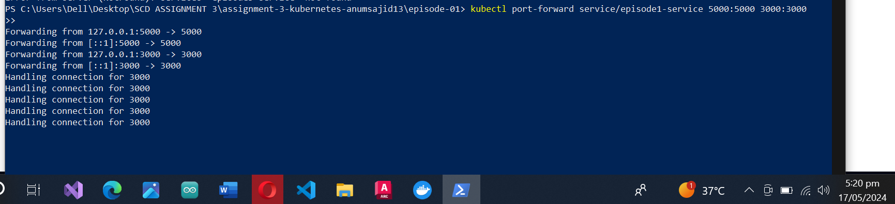

# **Episode 01**

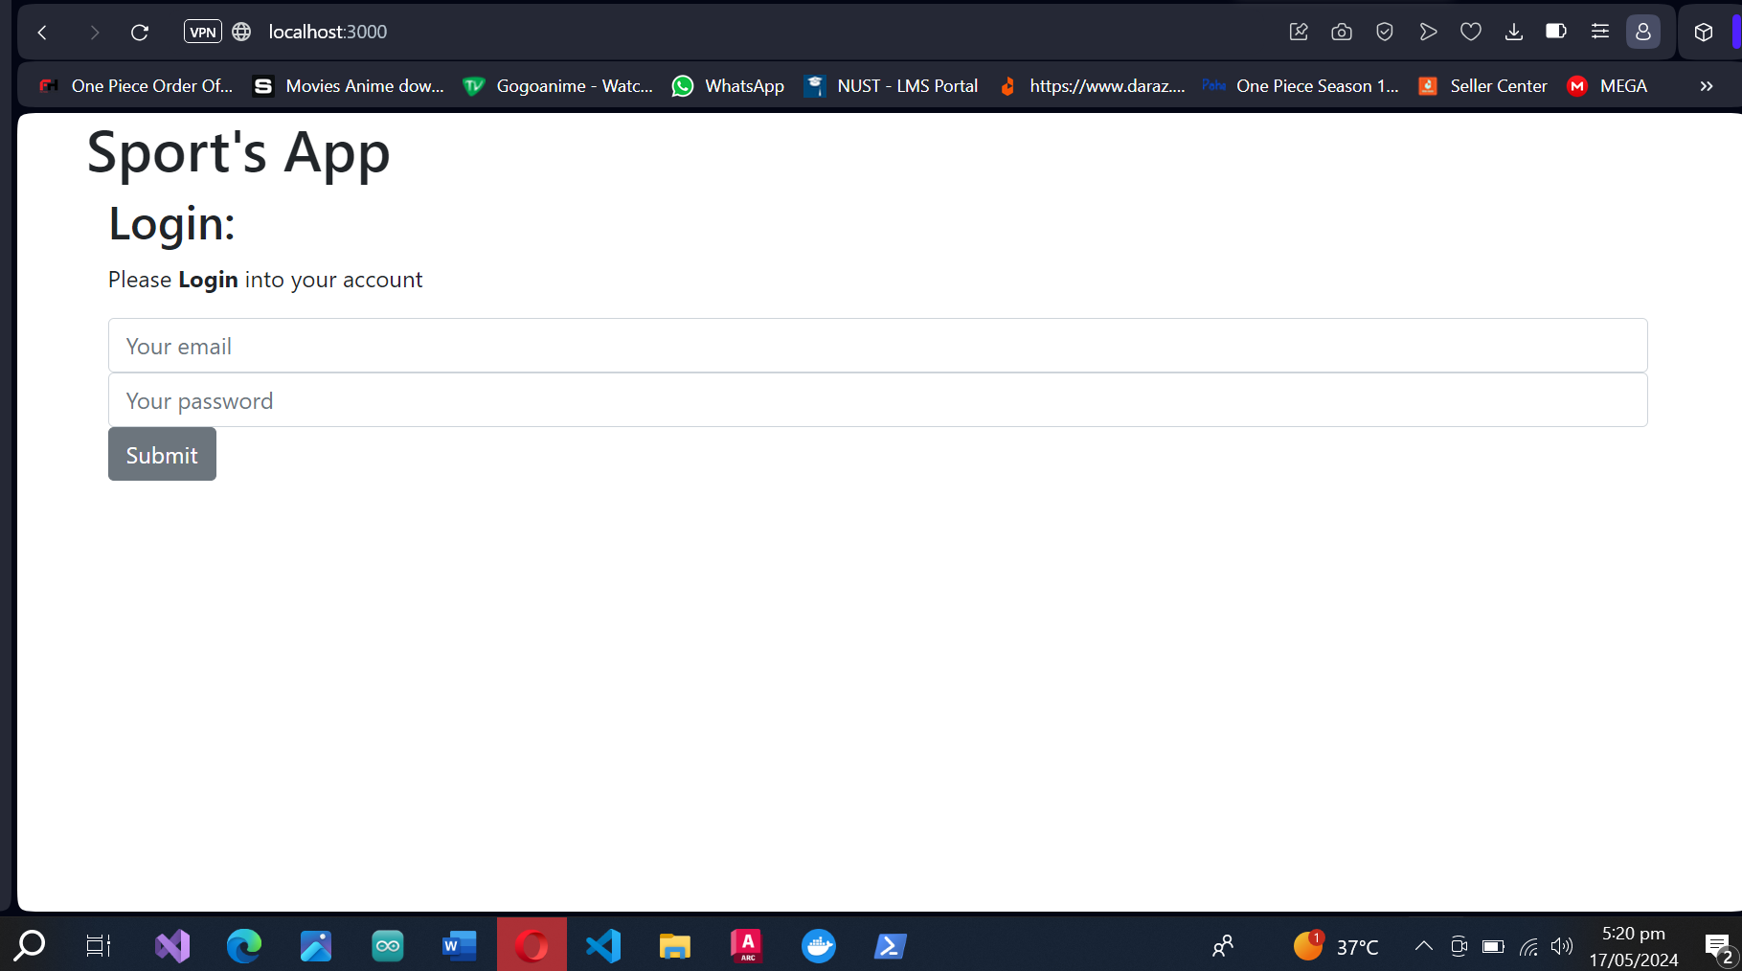

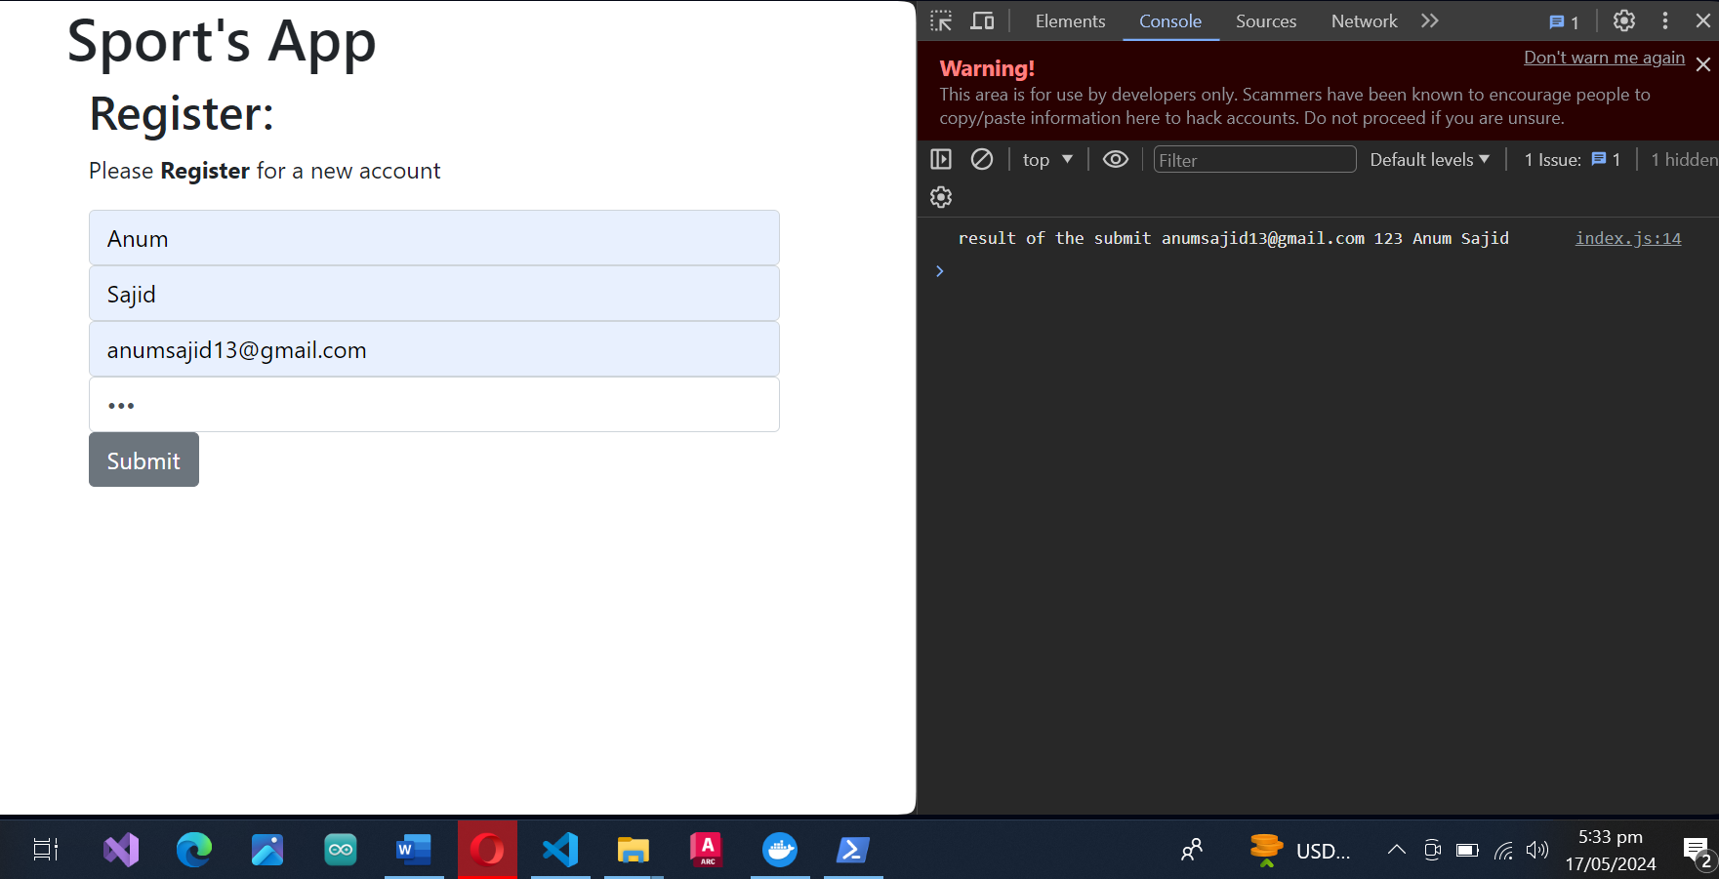

# **Episode 02**

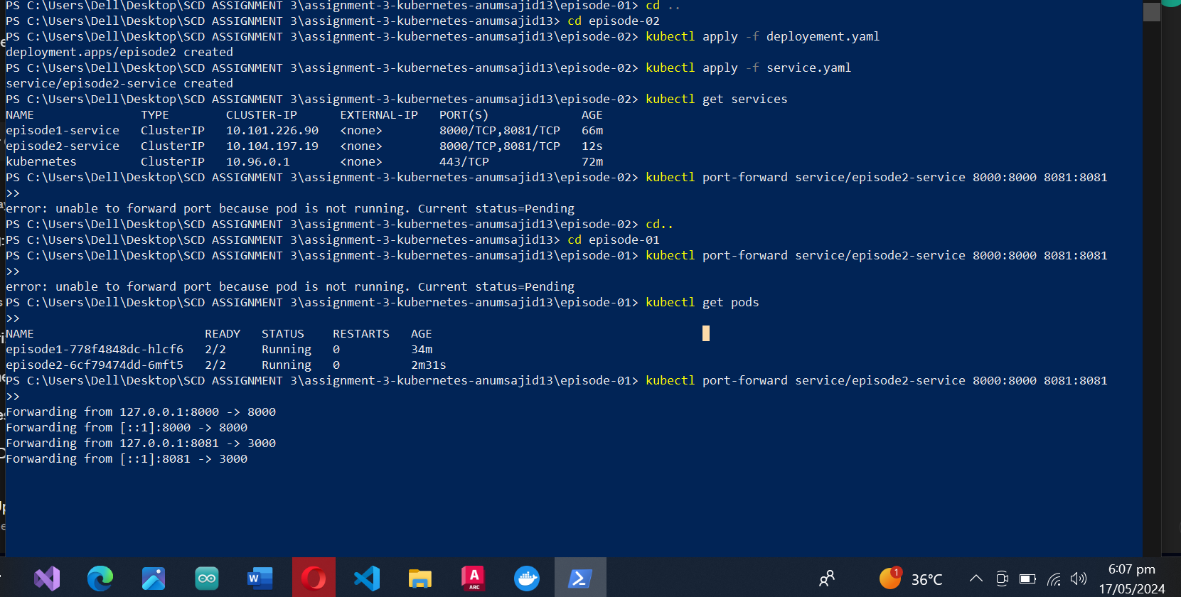

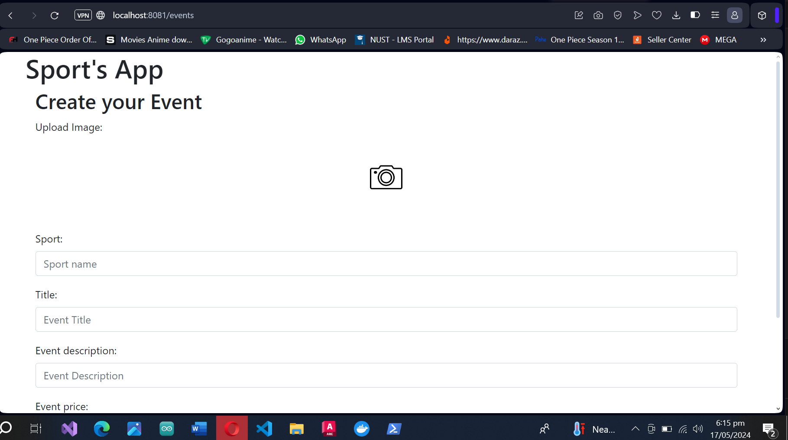

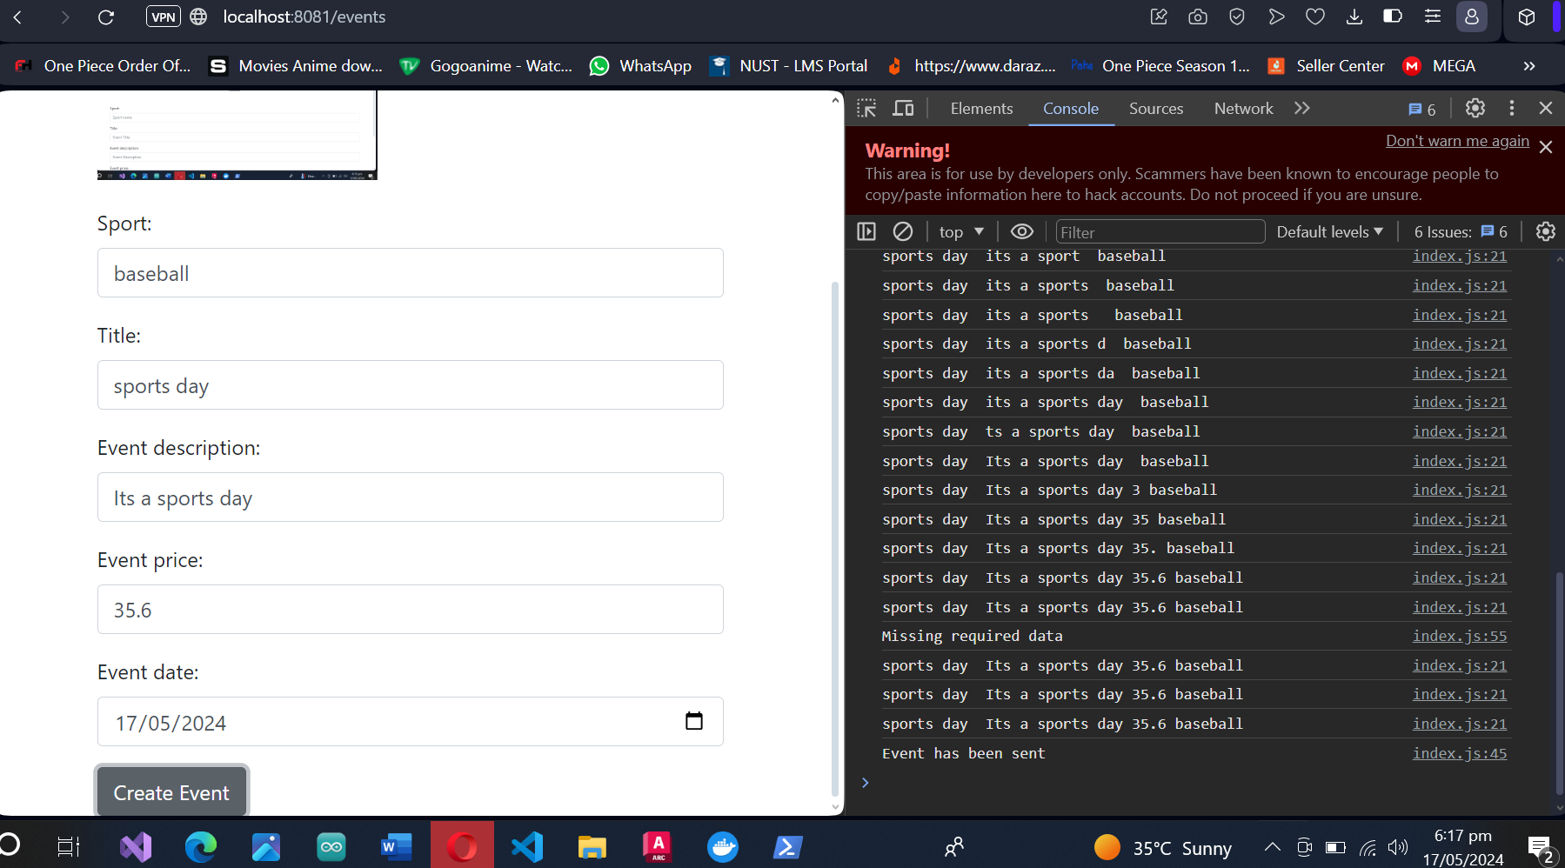

# **Episode 03**

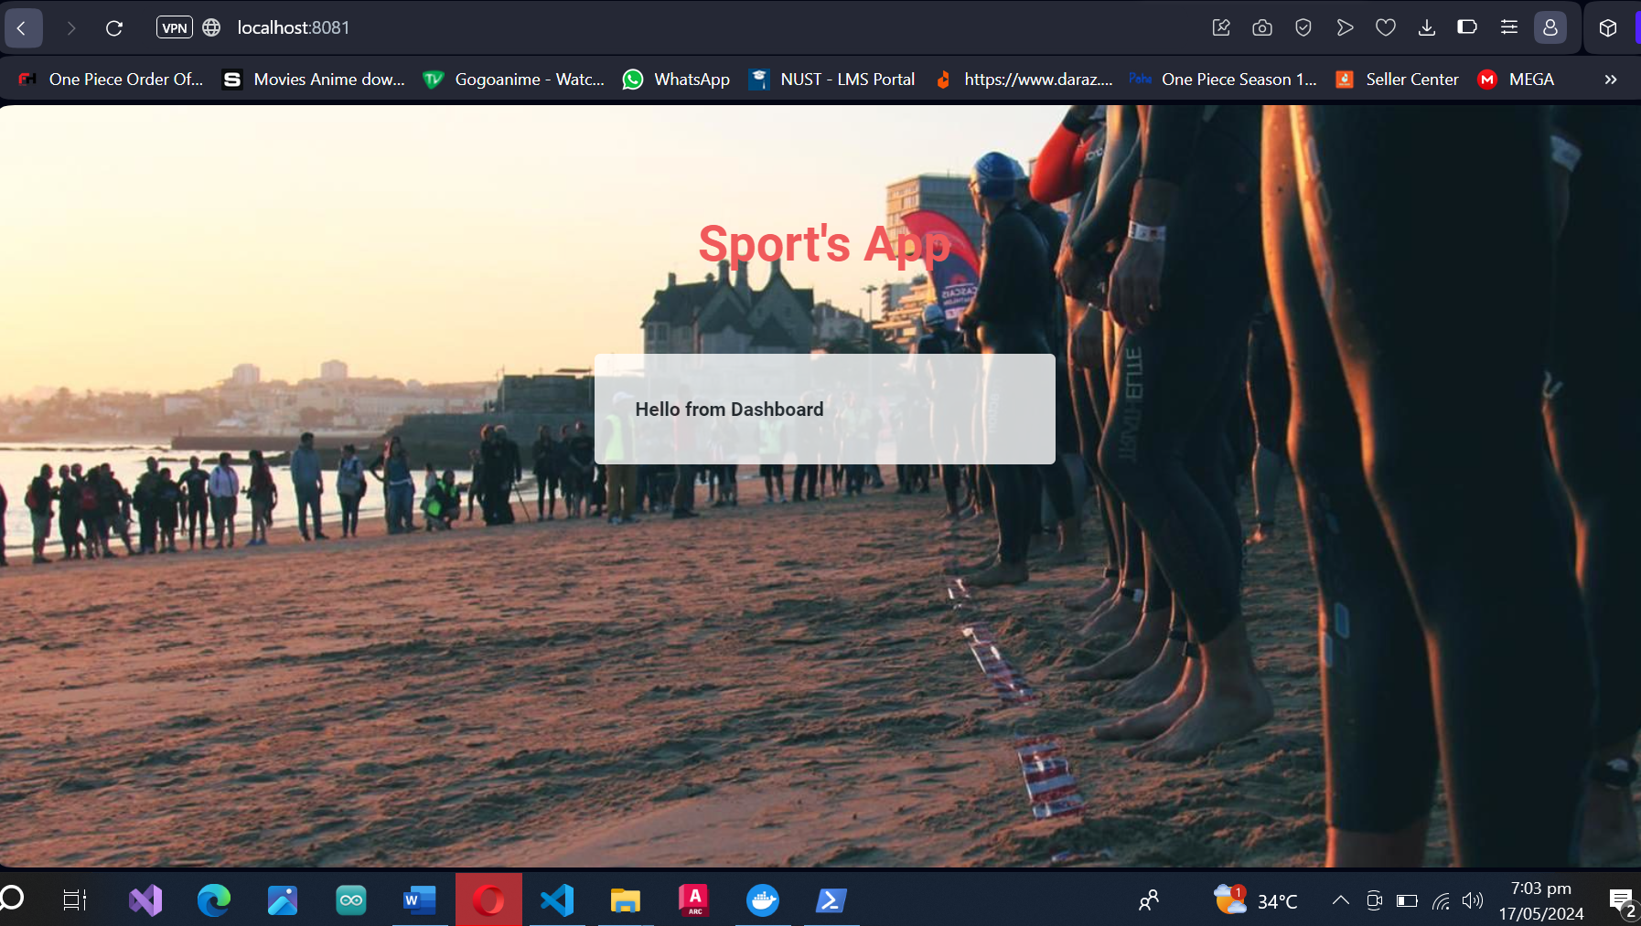

# **Episode 04**

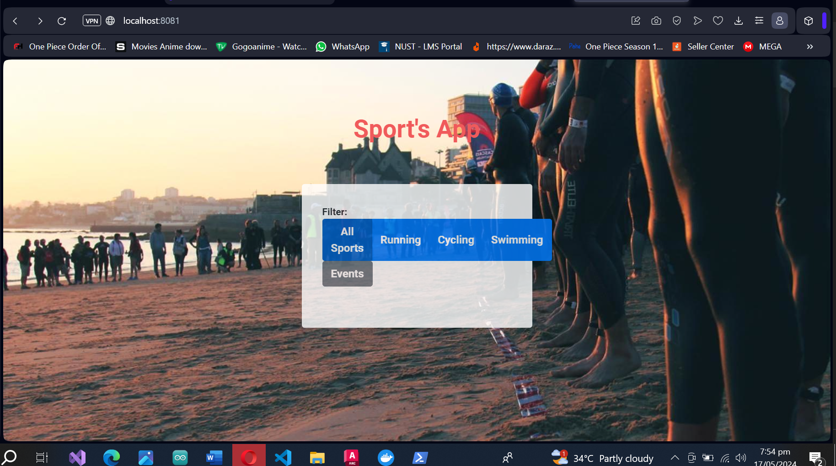

# **Episode 05**

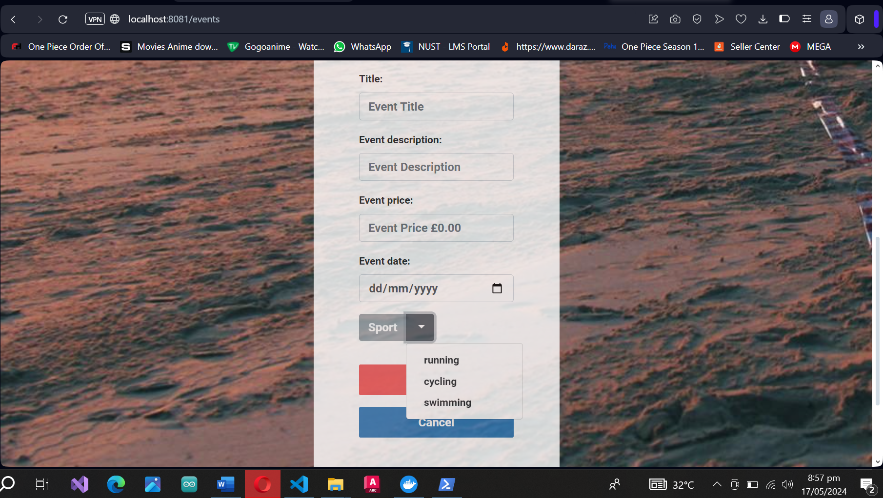

# **Kubernetes Dashboard**

## Setup

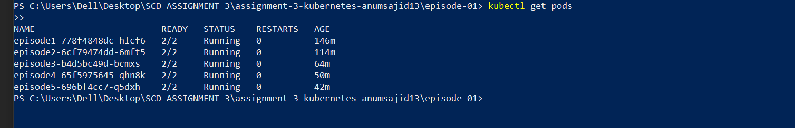

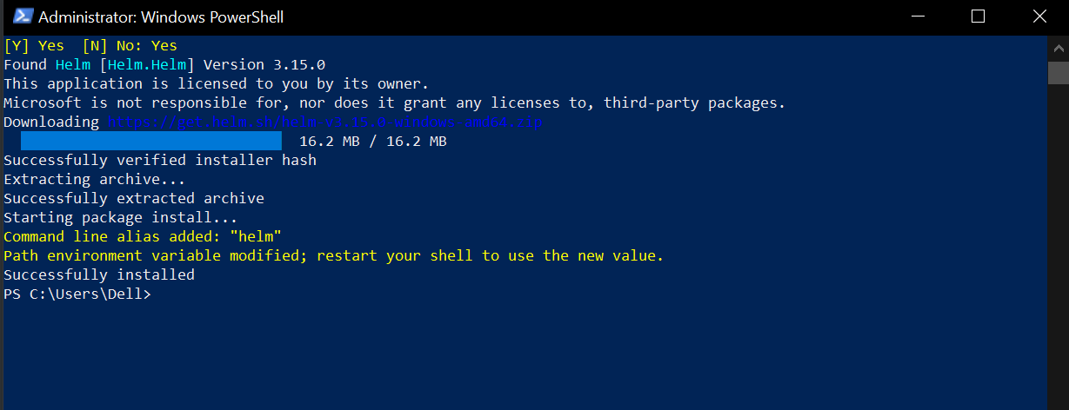

## Successful

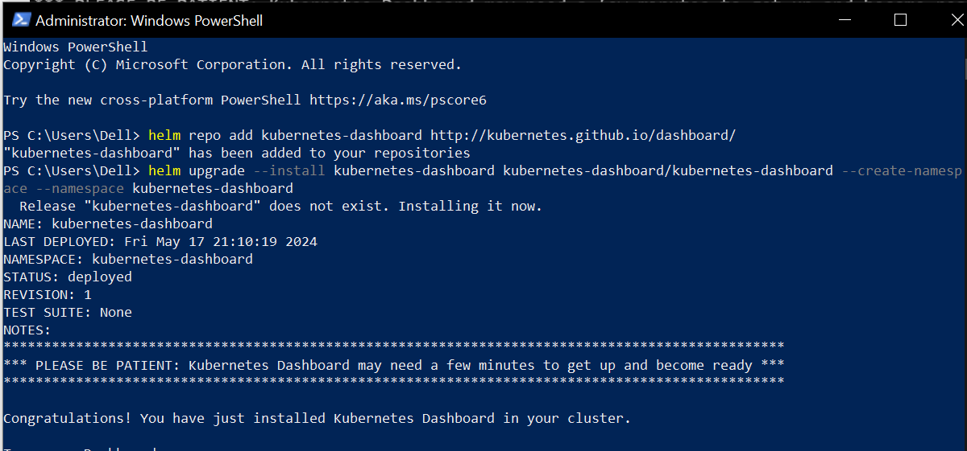

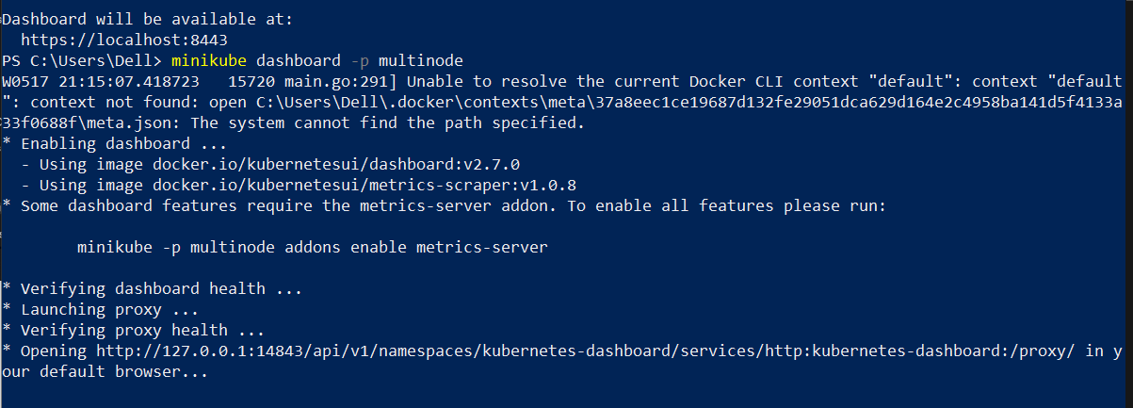

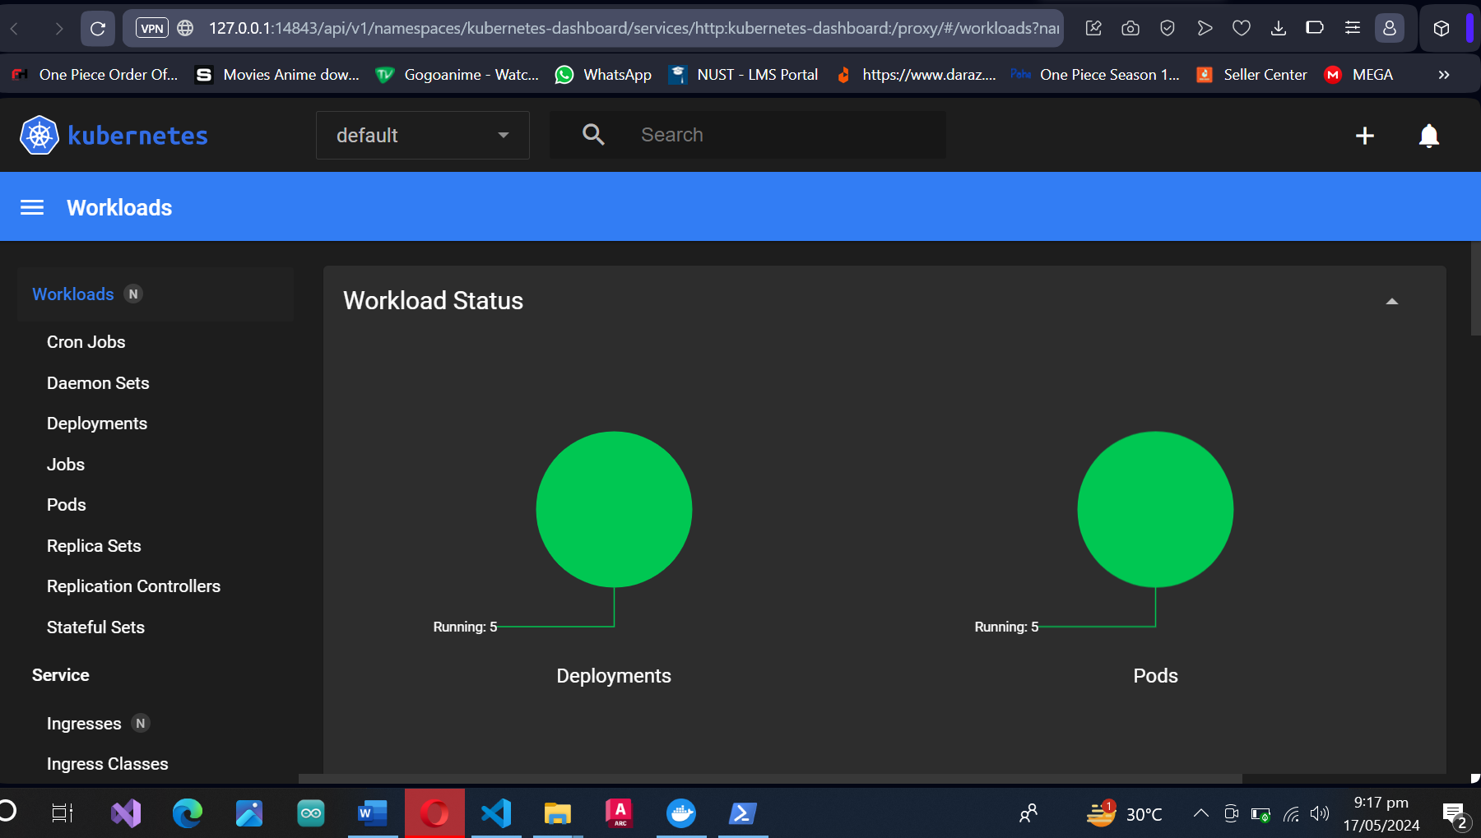

## View all deployments

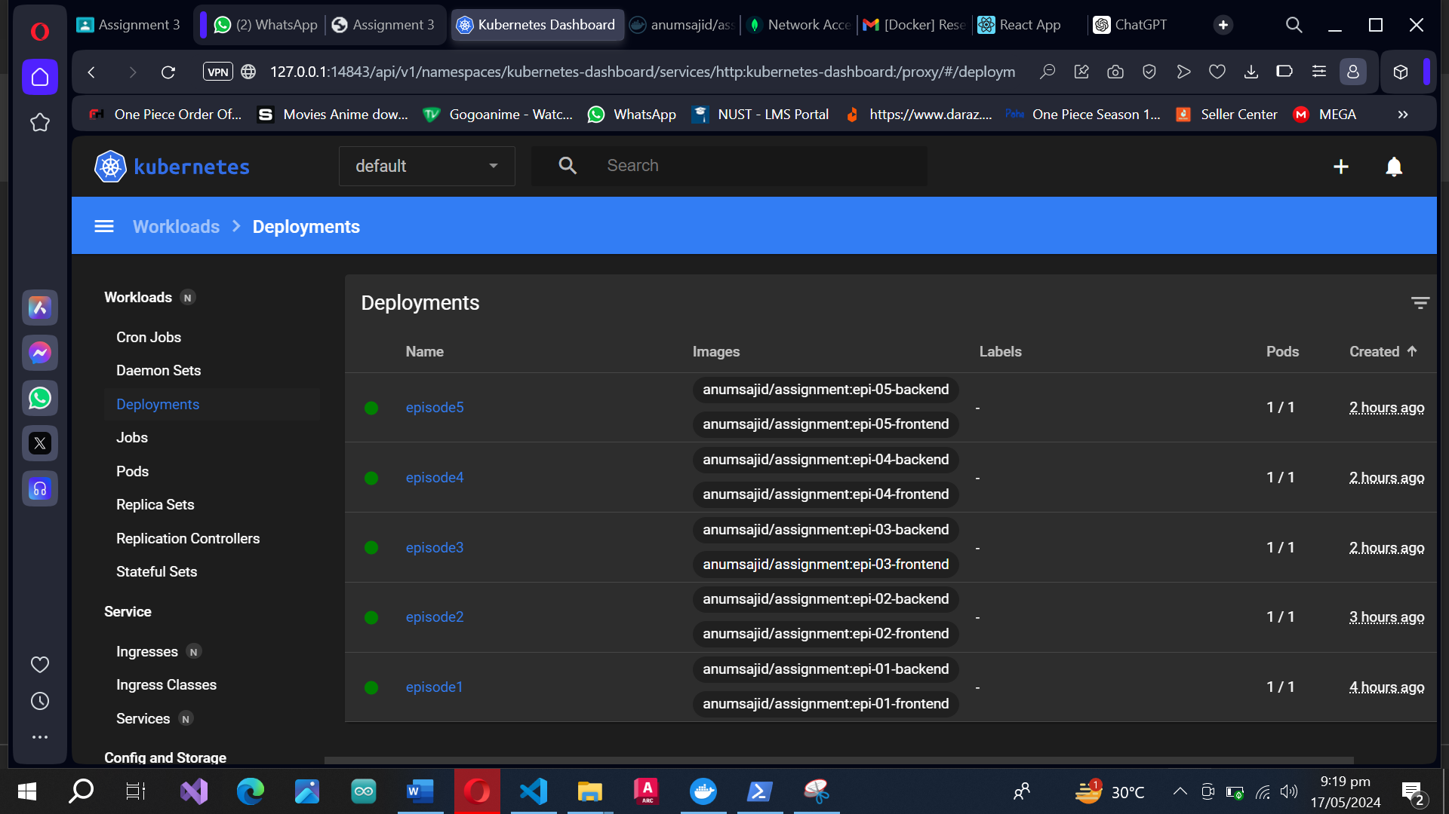

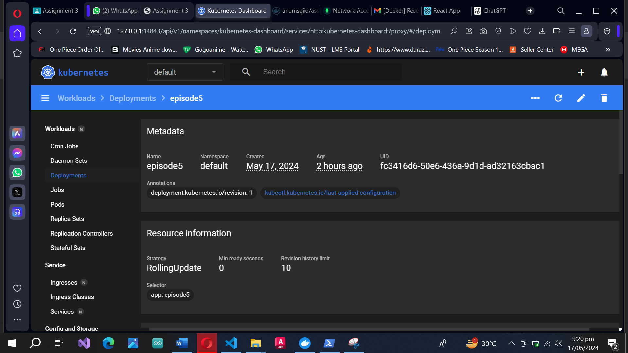

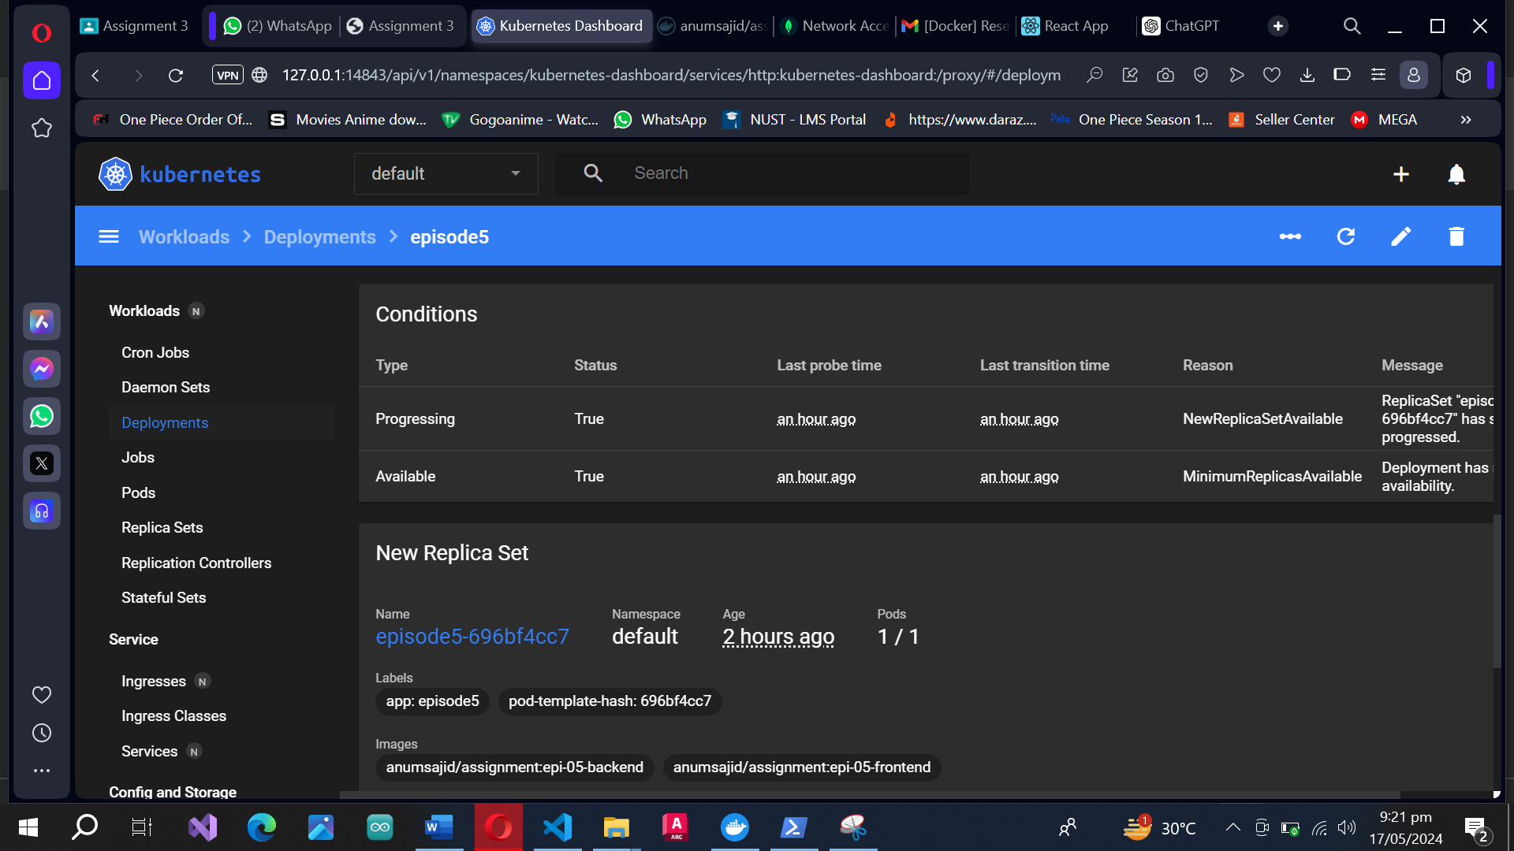

## Scaling the episode 5 to 6 replicas

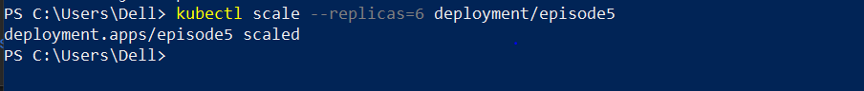

The change as a result of scaling is visible on the dashboard

